Module 9. Java I/O Fundamentals

Reading and Writing from Console

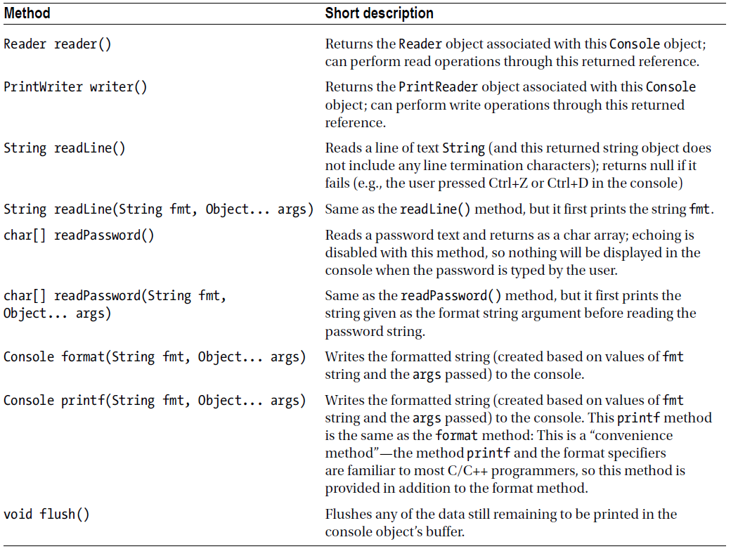

Table. Important Methods in the Console Class

Using Streams to Read and Write Files

Character Streams and Byte Streams

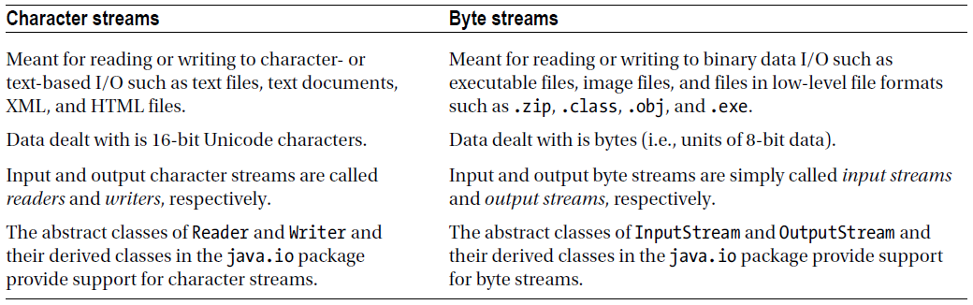

Table. Differences Between Character Streams and Byte Streams

Character Streams

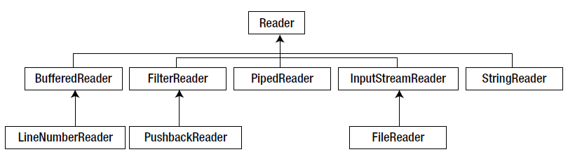

Figure. Important classes deriving from the Reader class

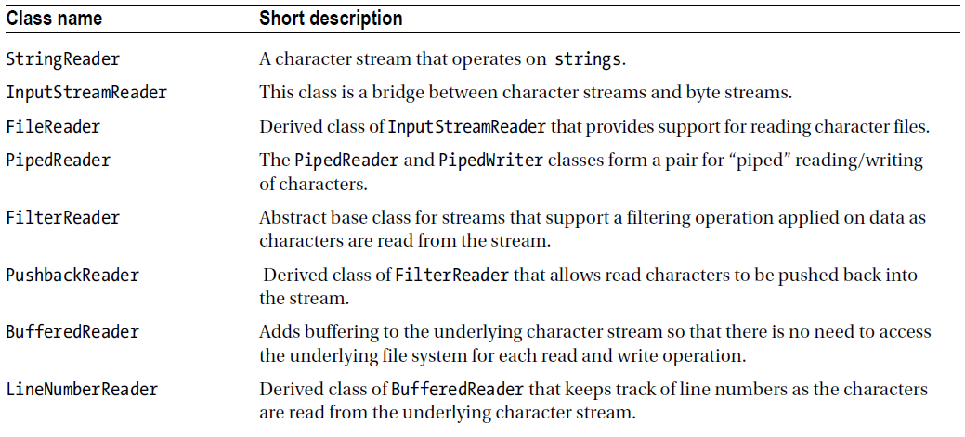

Table. Important Classes Deriving from the Reader Class

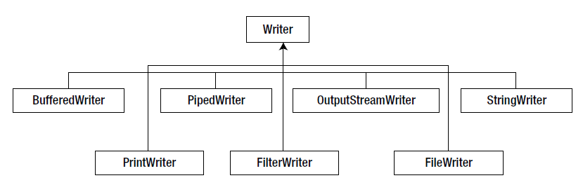

Figure. Important classes deriving from the Writer class

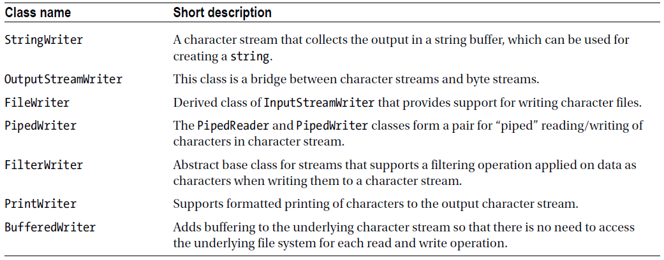

Table. Important Classes Deriving from the Writer Class

Byte Streams

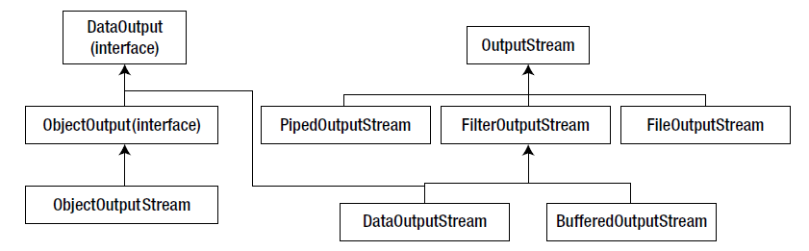

Figure. Important classes deriving from the OutputStream abstract class

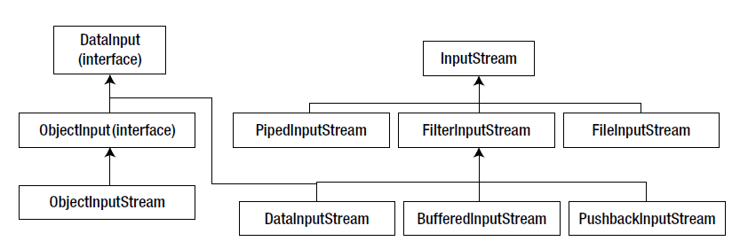

Figure. Important classes deriving from the InputStream abstract class

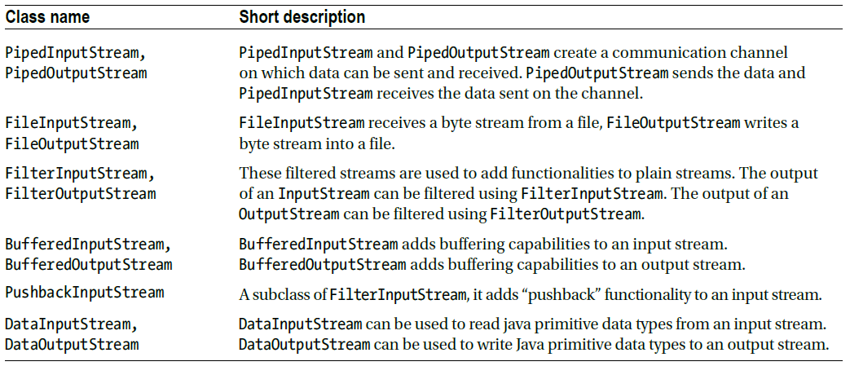

Table. Important Classes Deriving from the InputStream and OutputStream Classes

Questions

1. Consider the following code snippet:
USPresident usPresident = new USPresident("Barack Obama", "2009 to --", 56);
try (ObjectOutputStream oos = new ObjectOutputStream(new
FileOutputStream("USPresident.data"))){
oos.writeObject(usPresident);
usPresident.setTerm(57);
oos.writeObject(usPresident);
}
If you deserialize the object and print the field term (term is declared as int and is not a
transient), what it will print?
A. 56
B. 57
C. null
D. Compiler error
E. R untime exception

2. Consider the following code segment:
OutputStream os = new FileOutputStream("log.txt");
System.setErr(new PrintStream(os)); // SET SYSTEM.ERR
System.err.println("Error");
Which one of the following statements is true regarding this code segment?
A. T he line with comment SET SYSTEM.ERR will not compile and will result in a compiler error.
B. T he line with comment SET SYSTEM.ERR will result in throwing a runtime exception since System.err cannot be programmatically redirected.
C. T he program will print the text “Error” in console since System.err by default sends the output to console.
D. T his code segment redirects the System.err to the log.txt file and will write the text “Error” to that file.

3. Which one of the following definitions of the AResource class implementation is correct so that it can be used with try-with-resources statement?
a. class AResource implements Closeable {
protected void close() /* throws IOException */ {
// body of close to release the resource
}
}
B. class AResource implements Closeable {
public void autoClose() /* throws IOException */ {
// body of close to release the resource
}
}
C. class AResource implements AutoCloseable {
void close() /* throws IOException */ {
// body of close to release the resource
}
}
d. class AResource implements AutoCloseable {
public void close() throws IOException {
// body of close to release the resource
}
}

4. Consider the following code segment:
FileInputStream findings = new FileInputStream("log.txt");
DataInputStream dataStream = new DataInputStream(findings);
BufferedReader br = new BufferedReader(new InputStreamReader(dataStream));
String line;
while ((line = br.readLine()) != null) {
System.out.println(line);
}
br.close();
Which two options are true regarding this code segment?
A. br.close() statement will close only the BufferedReader object, and findings and dataStream will remain unclosed.
B. T he br.close() statement will close the BufferedReader object and the underlying stream objects referred by findings and dataStream.
C. T he readLine() method invoked in the statement br.readLine() can throw an IOException; if this exception is thrown, br.close() will not be called, resulting in a resource leak.
D. T he readLine() method invoked in the statement br.readLine() can throw an IOException; however, there will not be any resource leaks since Garbage Collector collects all resources.
E. In this code segment, no exceptions can be thrown calling br.close(), so there is no possibility of resource leaks.

